**Lab Practice 1 – Database Systems**

**Practice Question 1**

Show the structure of the DEPARTMENTS table AND Select all data from the table.

**See output below**



DESCRIBE departments

SELECT *

FROM departments;

**Answer:**

**Practice Question 2**

1. Show the structure of the EMPLOYEES table.
2. Create a query to display the last name, job code, hire date, and employee number for each employee, with employee number appearing first. Provide an alias STARTDATE for the HIRE_DATE column.

**See output below**

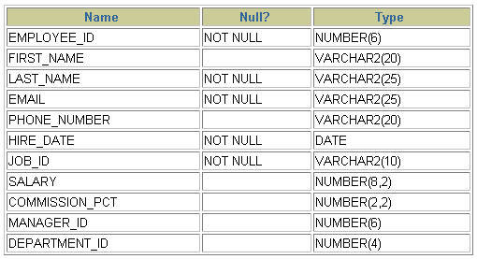

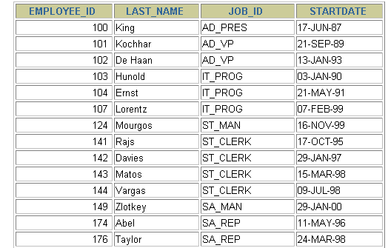

**Answer:**

**DESCRIBE employees**

**SELECT employee_id, last_name, job_id, hire_date “ STARTDATE”**

**FROM employees;**

**Practice Question 3**

Create a query to display unique job codes from the EMPLOYEES table.

**See output below**

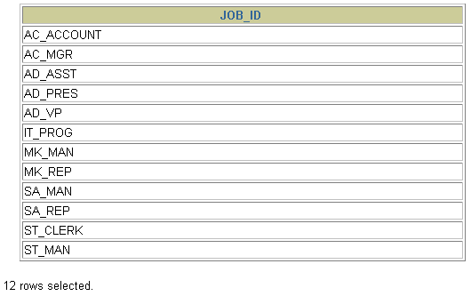

**Answer:**

**SELECT DISTINCT job_id**

**FROM employees;**

**Practice Question 4**

Show all employees data and show data under Column heading as Emp #, Employee, Job, and Hire Date, respectively.

**See output below**

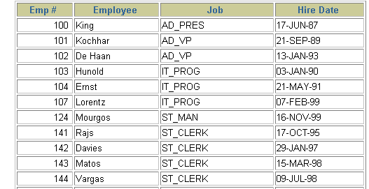

**Answer:**

**SELECT employee_id "Emp #", last_name "Employee",**

**job_id "Job", hire_date "Hire Date"**

**FROM employees;**

**Practice Question 5**

Display the last name concatenated with the job ID, separated by a comma and space, and name the column Employee and Title.

**See output below**

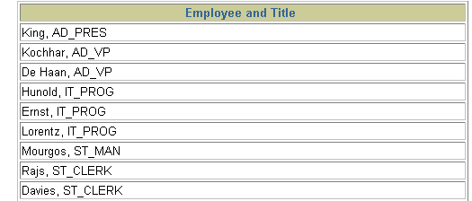

**Answer:**

**SELECT last_name||', '||job_id "Employee and Title"**

**FROM employees;**

**Practice Question 6**

Create a query to display all the data from the EMPLOYEES table. Separate each column by a  
comma. Name the column THE_OUTPUT.

**See output below**

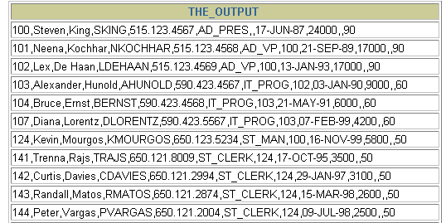

**Answers:**

**SELECT employee_id || ',' || first_name || ',' || last_name**

**|| ',' || email || ',' || phone_number || ','|| job_ id**

**|| ',' || manager_id || ',' || hire_date || ',' ||**

**salary || ',' || commission_pct || ',' || department _id**

**THE_OUTPUT**

**FROM employees;**